Focussed Search Pattern One

* **a name for the pattern: Filtering Checkboxes**
* **a wireframe picture**

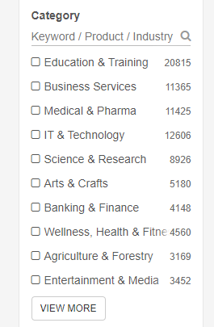

* **use when** (describes when the pattern should be applied)

1. Use when the number of search results is too big
2. Use when the user wants to focus on specific information
3. Use when search results can be categorized

* **how** (describes how the pattern may be applied)

The idea is to limit the number of search results and focus on more specific information. The pattern can be applied when user wants to search more specifically. User can tick checkboxes to filter the query results and narrow the search results. I am going to apply this pattern in my application by enabling the users to look for specific category of events.

* **a discussion of** how you have applied this pattern in your own information seeking.

Video link: https://drive.google.com/file/d/14AYkrU7NE4Nyj9smsNbg4ZU-P5QLgc5q/view

As you can see in the above video, this pattern works perfectly when the user wants to filter the results and search for more specific details. In my personal experience, when I want to narrow the search results and save time, I am always looking for using this feature. It is easy, and very comfortable, because the feedback is displayed instantly, so one can experiment to find the best filtering options.